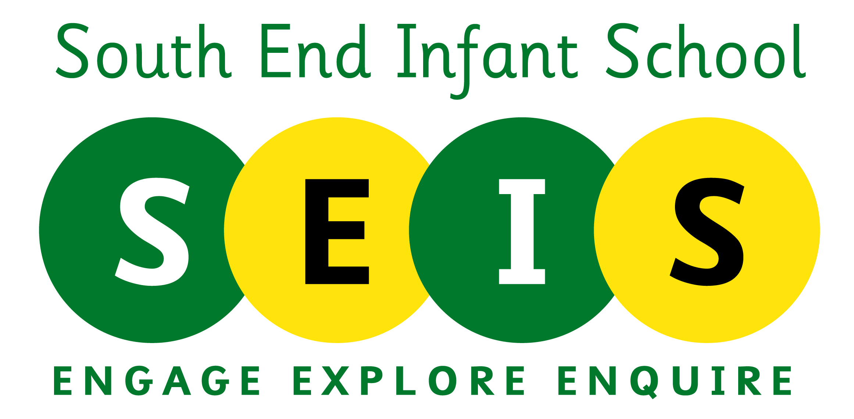 | Relationships, Health & Sex Education Policy
This policy was reviewed by the Full Governing Body:  November 23 |  | Coordinator:  E Ashcroft
Chair of Governors: Mrs Julie Rogers-Hussey |  | Review Date:  November 24
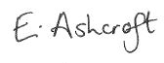  Head Teacher: |  | Review Date:  November 24

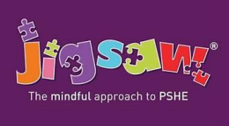
Introduction

At South End Infant School we provide a curriculum that is broadly based, balanced and meets the needs of all pupils. Under section 78 of the Education Act 2002 and the Academies Act 2010, a PSHE curriculum:
- Promotes the spiritual, moral, cultural, mental and physical development of pupils at the school and of society, and
- Prepares pupils at the school for the opportunities, responsibilities and experiences of later life.

An amendment to the Children and Social Work Act 2017 made Relationships and Health Education at primary; and Relationships, Sex, and Health Education at secondary, statutory subjects. The DfE guidance on Relationships, Health and Sex Education for governing bodies can be seen here.

Our school is confident that the Jigsaw Programme covers all aspects of Relationships, Sex and Health Education (RSHE) within the context of a full PSHE programme in an age-appropriate way. It has been chosen for this reason and also in order to link directly to the curriculum followed by South End Junior School.

This Jigsaw PSHE policy is also informed by DfE guidance on Relationships, Sex and Health Education (as above), preventing and tackling bullying (Preventing and tackling bullying: Advice for head teachers, staff and governing bodies, July 2013, updated 2017), Drug and Alcohol Education (DfE and ACPO drug advice for schools: Advice for local authorities, Head Teachers, school staff and governing bodies, September 2012), safeguarding (Working Together to Safeguard Children: A guide to inter-agency working to safeguard and promote the welfare of children, March 2013 and Keeping Children safe in Education 2023) and equality (Equality Act 2010: Advice for school leaders, school staff, governing bodies and local authorities, revised June 2014).

The Jigsaw Programme meets all the outcomes in the PSHE Association Programmes of Study, 2017.

Statement of Intent

To provide pupils with the knowledge, understanding, attitudes, values and skills they need in order to reach their potential as individuals and within the community.

Pupils are encouraged to take part in a wide range of activities and experiences across and beyond the curriculum, contributing fully to the life of our school and communities. In doing so they learn to recognise their own worth, work well with others and become increasingly responsible for their own learning. They reflect on their experiences and understand how they are developing personally and socially, tackling many of the spiritual, moral, social and cultural issues that are part of growing up.

They learn to understand and respect our common humanity; diversity and differences so that theycan go on to form the effective, fulfilling relationships that are an essential part of life and learning.

In our school we choose to deliver Personal, Social, Health Education using Jigsaw, the mindful approach to PSHE.

Objectives/Pupil learning intentions:

In our school, Jigsaw PSHE will support the development of the skills, attitudes, values and behaviour, which enable pupils to:
- Have a sense of purpose
- Value self and others
- Form relationships
- Make and act on informed decisions
- Communicate effectively
- Work with others
- Respond to challenge
- Be an active partner in their own learning
- Be active citizens within the local community
- Explore issues related to living in a democratic society
- Become healthy and fulfilled individuals

Jigsaw Content taught from Reception to Year 2

Jigsaw covers all areas of PSHE for the primary phase, as the table below shows:

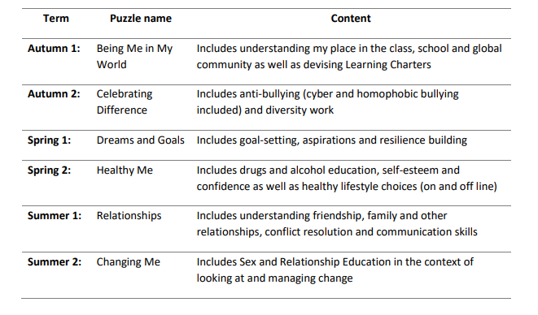

Relationship and Sex Education (Relationships, Sex and Health Education)

Definition of Relationships, Sex and Health Education (RSHE)

From September 2020, Relationships Education became compulsory for all primary schools as set out in the DfE Guidance (2019). For all maintained schools there is also a statutory duty to provide Health Education. This includes primary aged children learning about the ‘changing adolescent body’, included in the expected outcomes for primary Health Education. (Relationships Education, Relationships and Sex Education, and Health Education, DfE, 2019).

All primary schools are legally obliged to have an up-to-date policy for Relationships and Sex Education (RSE) that describes the content and organisation of RSE. In primary schools if the decision is taken to teach sex education beyond Relationships and Health Education and National curriculum Science, this should also be documented in the policy. The policy should be made available to parents/carers on request and also available on the school’s website. It is the school governors’ responsibility to ensure that the policy is developed and implemented effectively.

Effective Relationships and Sex Education can make a significant contribution to the development of the personal skills needed by pupils if they are to establish and maintain relationships. It also enables children and young people to make responsible and informed decisions about their health and wellbeing. This is why the DfE recommend:

“… that all primary schools should have a sex education programme tailored to the age and the physical and emotional maturity of the pupils. It should ensure that both boys and girls are prepared for the changes that adolescence brings and – drawing on knowledge of the human life cycle set out in the national curriculum for science - how a baby is conceived and born.” (Relationships Education, Relationships and Sex Education, and Health Education, DfE, 2019, para 67).

Compulsory aspects of Relationships, Sex and Health Education.

End of primary expectations and curriculum content is given in the Relationships Education, Relationships and Sex Education, and Health Education DfE guidance (2019). It is up to schools to determine how this is taught as part of a broad and balanced curriculum. Where a school delivers this as part of a whole programme of PSHE, such as Jigsaw, they are free to continue with this approach.

The sex education contained in National Curriculum science (Key Stages 1–4) is compulsory in maintained schools.

- ‘All children, including those who develop earlier than average, need to know about puberty before they experience the onset of physical changes’ (1.13)
- Children should learn ‘how a baby is conceived and born’ before they leave primary school (1.16)

RSHE plays a very important part in fulfilling the statutory duties all schools have to meet. RSHE helps children understand the difference between safe and abusive relationships and equips them with the skills to get help if they need it. It also teaches them about the importance of a healthy lifestyle and positive mental health, about online and off line safety. Schools have responsibilities for safeguarding and a legal duty to promote pupil well-being (Education and Inspections Act 2006 Section 38).

- Sex and Relationships Education (SRE) is an important part of PSHE Education (DfE, 2014).
- When any school provides RSE they must have regard to the Secretary of States guidance; this is a statutory duty. Ofsted will evaluate how schools help to ensure a healthy lifestyle for their children (Ofsted, 2019, Education Inspection Framework Para 28).
- It is compulsory for all maintained schools to teach the parts of sex education that fall under National Curriculum Science which must be taught to all pupils of primary and secondary age e.g. the biological aspects of puberty and reproduction (Education Act 1996, National Curriculum 2014).

Updated government safeguarding guidance is now available Keeping Children safe in Education 2023 and includes a section about being alert to signs that young girls may be at risk of female genital mutilation (FGM). School summer holidays especially during the transition from primary to secondary schools is thought to be a key risk time for FGM.

RSHE has clear links with other school policies aimed at promoting pupils’ spiritual, moral, social and
cultural development, including the:

- Anti-Bullying Policy
- Behaviour Policy
- Confidentiality Policy
- Drug and Alcohol Education Policy
- Equal Opportunities Policy
- Health and Safety Policy
- ICT Policy and Safe Internet Use Policy
- Inclusion Policy
- RE Policy
- Safeguarding/Child Protection Policy
- SMSC Policy
- Special Educational Needs Policy

The role of the Head Teacher and Governing body

It is the responsibility of the Governors to ensure that as well as fulfilling their legal obligations, the governing boards or management committee should also make sure that:

• all pupils make progress in achieving the expected educational outcomes in regard to RSHE;
• RSHE is well led, effectively managed and well planned;
• the quality of RSHE provision is subject to regular and effective self-evaluation;
• teaching is delivered in ways that are accessible to all pupils with SEND;
• clear information is provided for parents on the subject content and the right to request that their
child is withdrawn; and,
• the subjects are resourced, staffed and timetabled in a way that ensures that the school can fulfil
its legal obligations

The Head Teacher liaises with external agencies regarding the school RSHE programme and ensures that all adults who work with children on these issues are aware of the school policy, and that they work within this framework. The Head Teacher monitors this policy on a regular basis and reports to governors, when requested, on the effectiveness of the policy. Parents should be consulted on the RSE policy and have the opportunity to express their views. They also must be informed of the limits of their right to withdraw their child from sex education and have the opportunity to do so within these limits.

Monitoring and Review

The Governing Body monitors the RSE policy on an annual basis. The Governing Body gives serious consideration to any comments from parents about the sex education programme, and makes a record of all such comments. Governors require the Head Teacher to keep a written record, giving details of the content and delivery of the RSE programme that is taught in our school. Governors should scrutinise materials to check they are in accordance with the school’s ethos. Parents and carers have the right to see sample materials used within the teaching of RHSE and can do so by prior appointment with a member of staff, or at any open evening the school chooses to hold about this curriculum area. As Jigsaw materials are copyrighted the school is not permitted to put teaching materials on the public facing website, or provide electronic copies of materials to parents and carers at home.

Equalities

The Equality Act 2010 covers the way the curriculum is delivered, as schools and other education
providers must ensure that issues are taught in a way that does not subject pupils to discrimination.
Schools have a duty under the Equality Act to ensure that teaching is accessible to all children and
young people, including those who are lesbian, gay, bisexual and transgender (LGBT). Inclusive RSHE
will foster good relations between pupils, tackle all types of prejudice – including homophobia – and
promote understanding and respect. The Department for Education has produced advice on The
Equality Act 2010 and schools (DfE, 2014b).

Schools have a legal duty to promote equality (Equality Act, 2010) and to combat bullying (Education
Act, 2006) (which includes homophobic, sexist, sexual and transphobic bullying) and Section 4.2 of
the national curriculum (2014) states “Teachers should take account of their duties under equal
opportunities legislation that covers race, disability, sex, religion or belief, sexual orientation,
pregnancy and maternity, and gender reassignment.”
“Schools should be alive to issues such as everyday sexism, misogyny, homophobia and gender
stereotypes and take positive action to build a culture where these are not tolerated, and any
occurrences are identified and tackled. Staff have an important role to play in modelling positive
behaviours. School pastoral and behaviour policies should support all pupils.” (DfE, 2019)

Jigsaw Content at South End Infant School

The grid below shows specific RSE content for each year group:

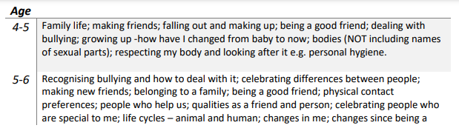
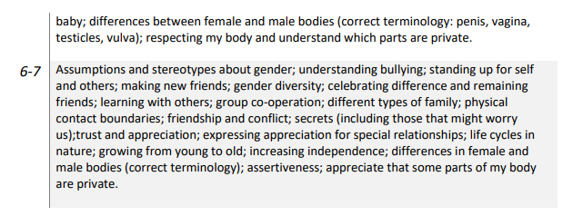

Withdrawal from RSE lessons

Parents/carers have the right to withdraw their children from Sex Education provided at school except for those parts included in statutory National Curriculum Science and that included within Statutory Relationships and Health Education. Those parents/carers wishing to exercise this right are invited in to see the head teacher and/or Jigsaw Lead in school who will explore any concerns and discuss any impact that withdrawal may have on the child. Once a child has been withdrawn they cannot take part in the specific sex education lessons until the request for withdrawal has been removed. Materials are available to parents/carers who wish to supplement the school sex education programme or who wish to deliver sex education to their children at home. Parents and carers cannot withdraw from any aspect of Relationships Education and also in maintained schools, Health Education lessons covering the changing adolescent body (puberty).

Working with parents and carers

The government guidance on Relationships, Sex Education and Health Education (DfE, 2019)
emphasises the importance of schools working in partnership with parents and carers.
Parents/carers should be aware that we are legally required to provide a broad and balanced
curriculum. Sex and relationships topics can arise incidentally in other subjects, such as Science,
Geography, History, RE, and it is not possible to withdraw pupils from these relatively limited and
often unplanned discussions. Parents should be given every opportunity to understand the purpose
and content of Relationships Education and RSHE. Good communication and opportunities for
parents to understand and ask questions about the school’s approach can help increase confidence
in the curriculum.

Health Education including substance education, mental health education and safety education

Effective Health Education can make a significant contribution to the development of the personal
skills needed by pupils as they grow up. It also enables young people to make responsible and
informed decisions about their own and others’ health and well-being.

Moral and Values Framework
The Health Education programme at our school reflects the school ethos and demonstrates and
encourages the following values. For example:
- Respect for self
- Respect for others
- Responsibility for their own actions
- Responsibility for their family, friends, schools and wider community

Jigsaw’s Health Education Content
The grid below shows specific Health Education content for each year group:
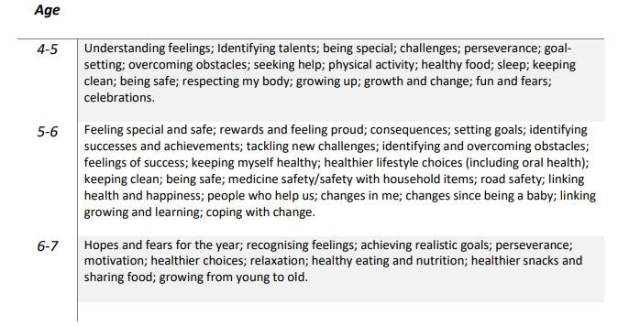
How is Jigsaw PSHE organised in our school?

Jigsaw brings together PSHE Education, emotional literacy, social skills and spiritual development in
a comprehensive scheme of learning. Teaching strategies are varied and are mindful of preferred
learning styles and the need for differentiation. Jigsaw is designed as a whole school approach, with
all year groups working on the same theme (Puzzle) at the same time. This enables each Puzzle to
start with an introductory assembly, generating a whole school focus for adults and children alike.

There are six Puzzles in Jigsaw that are designed to progress in sequence from Autumn to Summer.
Each Puzzle has six Pieces (lessons) which work towards an ‘end product’, for example, The School
Learning Charter or The Garden of Dreams and Goals.

Each Piece (lesson) has two Learning Intentions: one is based on specific PSHE learning (covering the
non-statutory national framework for PSHE Education and the statutory Relationships and Health
Education guidance, but enhanced to address children’s needs today); and one is based on
emotional literacy and social skills development to enhance children’s emotional and mental health.
The enhancements mean that Jigsaw, the mindful approach to PSHE, is relevant to children living in
today’s world as it helps them understand and be equipped to cope with issues like body image,
cyber and homophobic bullying, and internet safety.

Every Piece (lesson) contributes to at least one of these aspects of children’s development. This is
mapped on each Piece and balanced across each year group.

Differentiation/SEN

Jigsaw is written as a universal core curriculum provision for all children. Inclusivity is part of its
philosophy. Teachers will need, as always, to tailor each Piece (lesson) to meet the needs of the
children in their classes. To support this differentiation, many Jigsaw Pieces (lessons) suggest
creative learning activities that allow children to choose the media with which they work and give
them scope to work to their full potential. If any changes are implemented nationally as a result of
the Rochford Review Jigsaw will make the necessary amendments and offer this free update to all its
schools.

Safeguarding

Teachers need to be aware that sometimes disclosures may be made during Jigsaw lessons; in which
case, safeguarding procedures must be followed immediately. Sometimes it is clear that certain
children may need time to talk one-to-one after the lesson closes. It is important to allow the time
and appropriate staffing for this to happen. If disclosures occur, the school’s disclosure and/or
confidentiality policy is followed.

Assessment

Teachers will be eager to ensure children are making progress with their learning throughout their
Jigsaw experience. Our school will initially assess through observation of interactions and children’s
use of common language. Staff will discuss the effectiveness of Jigsaw and feedback to the PSGE
lead. The PSHE leader will carry out learning walks and lesson observations where pupils will be
asked how they feel about Jigsaw.

Recording and tracking progress

To support the teacher in tracking each child’s Jigsaw Learning progress throughout the year, there is
a Pupil Tracking Grid. This sheet has the three attainment descriptors for each Puzzle. After each
Puzzle is completed, the teacher, using a best-fit approach, decides whether the child is working at,
towards or beyond and highlights the appropriate descriptor box on that child’s overview sheet.
There is also space for the teacher’s comments. This sheet gives a quick visual representation of
where the child is in each Puzzle.

Reporting to Parents/Carers

Each Puzzle’s assessment tasks, attainment and children’s Jigsaw Journals assist the teacher in
reporting meaningful learning progress to parents/carers. The descriptors can be used as a starting
point when considering what to write on children’s reports.

The Attainment Descriptors

Please be aware that these attainment descriptors are specific to Jigsaw and to year groups. They
are designed to give guidance when considering each child’s learning journey. They are not
nationally-recognised. There are no national level descriptors for PSHE.

The Jigsaw philosophy is that children are praised and their achievements celebrated in every Piece
(lesson). It demands a positive relationship between the teacher and the children which, in itself,
values and celebrates each individual. Appropriate time is allocated for this process.

Monitoring and evaluation

The PSHE co-ordinator will monitor delivery of the programme through observation and discussion
with teaching staff to ensure consistent and coherent curriculum provision.
Evaluation of the programme’s effectiveness will be conducted on the basis of:
- Pupil and teacher evaluation of the content and learning processes
- Staff meetings to review and share experience

External contributors

External contributors from the community, e.g. health promotion specialists, school nurses, social
workers, and community police and fire officers, make a valuable contribution to the Jigsaw PSHE
programme. Their input should be carefully planned and monitored so as to fit into and
complement the programme.

Teachers MUST always be present during these sessions and remain responsible for the delivery of
the Jigsaw PSHE programme.

The Learning Environment

Establishing a safe, open and positive learning environment based on trusting relationships between
all members of the class, adults and children alike, is vital. To enable this, it is important that ‘ground
rules’ are agreed and owned at the beginning of the year and are reinforced in every Piece (lesson) –
by using The Jigsaw Charter. (Ideally, teachers and children will devise their own Jigsaw Charter at
the beginning of the year so that they have ownership of it.) It needs to include the aspects below:

The Jigsaw Charter

- We take turns to speak
- We use kind and positive words
- We listen to each other
- We have the right to pass
- We only use names when giving compliments or when being positive
- We respect each other’s privacy (confidentiality)

Teaching Sensitive and Controversial Issues

Sensitive and controversial issues are certain to arise in learning from real-life experience. Our
teachers will be prepared to handle personal issues arising from the work, to deal sensitively with,
and to follow up appropriately, disclosures made in a group or individual setting. Issues that we
address that are likely to be sensitive and controversial because they have a political, social or
personal impact or deal with values and beliefs include: family lifestyles and values, physical and
medical issues, financial issues, bullying and bereavement.

Our teachers will take all reasonable, practical steps to ensure that, where political or controversial
issues are brought to pupils’ attention, they are offered a balanced presentation of opposing views.
Teachers will adopt strategies that seek to avoid bias on their part and will teach pupils how to
recognise bias and evaluate evidence. We will seek to establish a classroom climate in which all
pupils are free from any fear of expressing reasonable points of view that contradict those held
either by their class teachers or their peers.

Answering Difficult Questions and Sensitive Issues

Staff members are aware that views around RSE and Drug and Alcohol Education-related issues are
varied. However, while personal views are respected, all RSE and Drug and Alcohol Education issues
are taught without bias using Jigsaw. Topics are presented using a variety of views and beliefs so
that pupils are able to form their own, informed opinions but also respect that others have the right
to a different opinion.

Both formal and informal RSE and Drug and Alcohol Education arising from pupils’ questions are
answered according to the age and maturity of the pupil(s) concerned. Questions do not have to be
answered directly, and can be addressed individually later. The school believes that individual
teachers must use their skill and discretion in this area and refer to the Safe Guarding Lead (or
Deputy) if they are concerned.

Our school believes that RSE and Drug and Alcohol Education should meet the needs of all pupils,
answer appropriate questions and offer support. In Jigsaw Pieces that cover RSE provision, this
should be regardless of their developing sexuality and be able to deal honestly and sensitively with
sexual orientation, answer appropriate questions and offer support. Homophobic bullying is dealt
with strongly yet sensitively. The school liaises with parents/carers on this issue to reassure them of
the content and context.

Involving parents and carers

In our setting, we believe that it is important to have the support of parents, carers and the wider
community for the Jigsaw PSHE programme. Parents and carers are/will be given the opportunity to
find out about and discuss the Jigsaw PSHE programme through:
- Parent/carer Jigsaw awareness session
- Parents’/carers’ evenings
- Involvement in policy development
- Involvement in curriculum development
- Information leaflets/displays

Pupil Consultation:

- It is useful for pupils to be consulted on their own personal, social and citizenship development. Ask pupils either in individual classes or through the school council what sort of person they would like to be by the time they leave this school; what qualities, skills, attitudes, values are important to them as people?
- Develop this further by asking pupils how they feel the school could support them with this, what initiatives the school could implement to support this e.g. friendship benches, peer mentoring systems.

Links to other policies and curriculum areas
We recognise the clear link between Jigsaw PSHE and the following policies and staff are aware of
the need to refer to these policies when appropriate.
- Science curriculum
- Teaching and Learning Policy
- Equal Opportunities Policy
- Child Protection Policy

Training and support for staff

All staff benefit from Jigsaw PSHE training in order to enhance their PSHE delivery skills.
Opportunities are provided for staff to identify individual training needs on a yearly basis and
relevant support is provided.

In addition to this, support for teaching and understanding PSHE issues is incorporated in our staff
INSET programme, drawing on staff expertise and/or a range of external agencies.

Dissemination

This policy is available on our school website where it can be accessed by the community. Training is
regularly delivered to staff on the policy content. Copies are available from the school office on
request from parents/carers.

Confidentiality and Child Protection/Safeguarding Issues

As a general rule a child’s confidentiality is maintained by the teacher or member of staff concerned.
If this person believes that the child is at risk or in danger, she/he talks to the named Safe Guarding
Lead who takes action as laid down in the Child Protection Policy. All staff members are familiar with
the policy and know the identity of the member of staff with responsibility for Child Protection
issues. The child concerned will be informed that confidentiality is being breached and reasons why.
The child will be supported by the teacher throughout the process.

