Jigsaw & the RHE Curriculum
The other topics in the Jigsaw Curriculum are also taught each half term across the school but, again, at an age appropriate level.
Topic Title | Reception | Year 1 | Year 2
Being Me in My World | Self-identity  Understanding feelings  Being in a classroom  Being gentle  Rights and responsibilities | Feeling special and safe Being part of a class  Rights / responsibilities  Rewards/feeling proud  Consequences  Learning Charter | Hopes and fears this year  Rights and responsibilities  Rewards and consequences  Safe and fair learning environment  Valuing contributions  Choices  Recognising feelings
Celebrating Difference | Identifying talents  Being special  Families  Where we live  Making friends  Standing up for yourself | Similarities / differences Understanding bullying and knowing how to deal with it  Making new friends  Celebrating the differences in everyone | Assumptions and stereotypes about gender  Understanding bullying  Standing up for self and others  Making new friends  Gender diversity  Celebrating difference
Dreams and Goals | Challenges  Perseverance  Goal-setting  Overcoming obstacles  Seeking help  Jobs  Achieving goals | Setting goals  Successes/achievements  Learning styles  Working well and celebrating achievement with a partner Tackling new challenges  Identifying and overcoming obstacles  Feelings of success | Achieving realistic goals  Perseverance  Learning strengths  Learning with others  Group co-operation  Contributing to and sharing success
Healthy Me | Exercising bodies  Physical activity  Healthy food  Sleep  Keeping clean  Safety | Keeping myself healthy  Healthier lifestyle choices Keeping clean  Being safe  Medicine safety/safety with  household items  Road safety  Linking health & happiness | Motivation  Healthier choices  Relaxation  Healthy eating and nutrition  Healthier snacks and sharing food
Relationships | Family life  Friendships  Breaking friendships  Falling out  Dealing with bullying  Being a good friend | Belonging to a family  Making friends/being a good friend  Physical contact preferences  People who help us  Qualities as a friend & person  Self-acknowledgement  Being a good friend to myself  Celebrating special relationships | Different types of family  Physical contact boundaries  Friendship and conflict  Secrets  Trust and appreciation  Expressing appreciation for special relationships
Changing Me | Bodies  Respecting my body  Growing up  Growth and change  Fun and fears  Celebrations | Life cycles – animal and human  Changes in me  Changes since being a baby  Differences between female and male bodies (correct terminology)  Linking growing and learning  Coping with change  Transition | Life cycles in nature  Growing from young to old  Increasing independence  Differences in female and male bodies (correct terminology)  Assertiveness  Preparing for transition

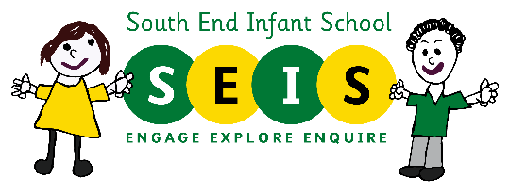

Relationship and Sex Education
at South End Infant School
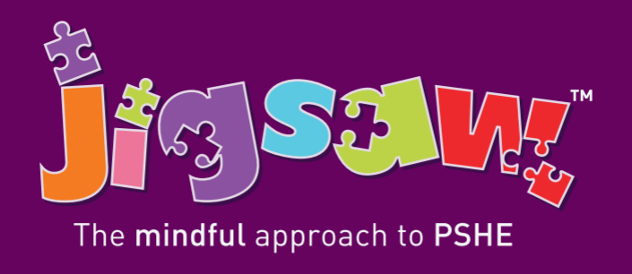

jigsawpshe.com
A Guide for Parents / Carers
March 2021

What is Relationship and Sex Education?
From September 2020 Relationships Education has become a statutory subject for Primary Schools in England.

South End Infant School and South End Junior School are both following the Jigsaw Programme to deliver their RSE Curriculum ensuring that all children receive a cohesive and age appropriate education in a format that will be familiar throughout their Primary Education.

What are the aims of RSE?
There are four main aims for teaching RSE within the context of Primary School PSHE (Personal, Social, Health Education):

• To enable young people to understand and respect their bodies, and be able to cope with the changes puberty brings, without fear or confusion

• To help young people develop positive and healthy relationships appropriate to their age, development etc. (respect for self and others)

• To support young people to have positive self-esteem and body image, and to understand the influences and pressures around them

• To empower them to be safe and safeguarded

This leaflet is designed to give Parents / Carers information about which aspects of the Jigsaw RSE will be taught within our Infant School setting.
What is Jigsaw, the mindful approach to PSHE?

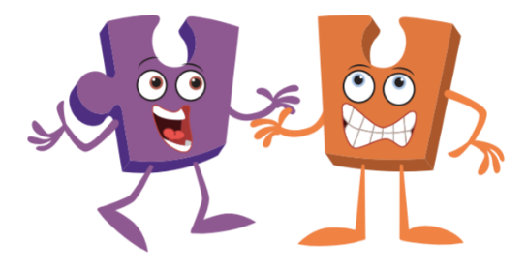
Jigsaw PSHE aims to support schools to work in partnership with parents and carers to ensure appropriate, relationship and sex education in the context of the PSHE.
The Jigsaw PSHE relationship and sex education units of work aim to give children their entitlement to information about relationships, puberty and human reproduction, appropriate to their ages and stages of development. This work is treated in a matter-of-fact and sensitive manner to allay embarrassment and fear and helps children to cope with change, including puberty and to learn about families, friendships and healthy relationships. Jigsaw aims to build the positive.

What will my child taught specifically in Sex Education?

The ‘Changing Me’ unit is taught over 6 weeks in the final summer term each year. Each Year Group is taught appropriate content to their age and developmental stage. Any questions that a teacher feels are beyond the remit of the Year Group will be directed back to parents. In our Infant Setting the content of this part of Jigsaw is:


